**Steps to create the configuration in TIBCO API Gateway (For Request Reload API)**

1. Login to ConfigUI portal

<http://adtibweb04f.privatecloud.local:9200/ConfigUI/>

1. Login using admin/admin
2. Create new Façade Operation under Routing tab as shown below.

(*Here {partner} will be the authenticated partner of the incoming request*.)

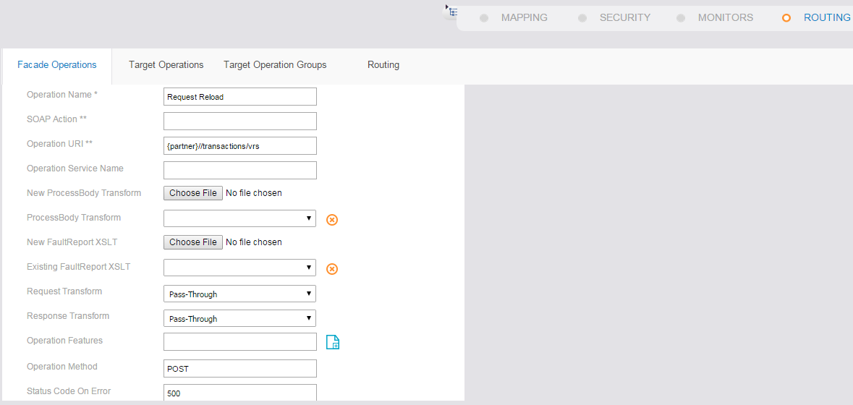

1. Create a new Target operation and provide the target operation details as shown below.

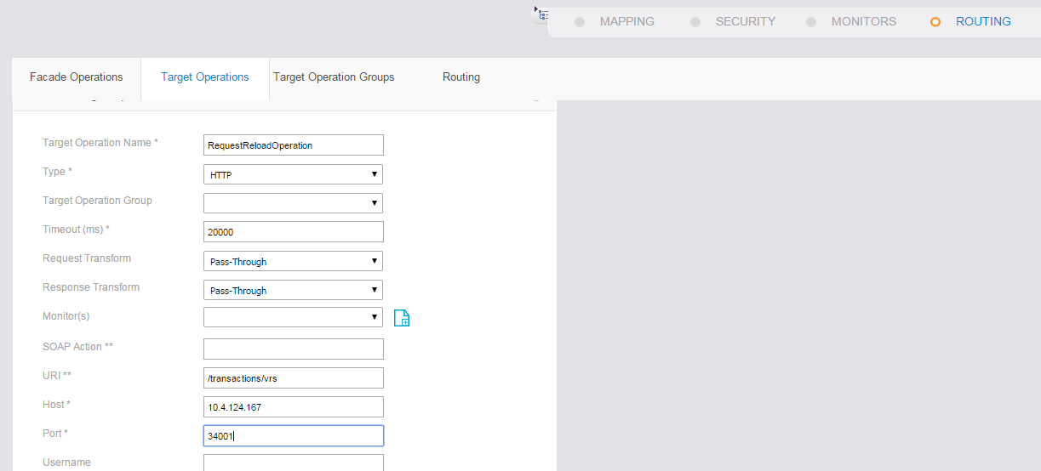

1. Create a route between the façade and Target Operation created.

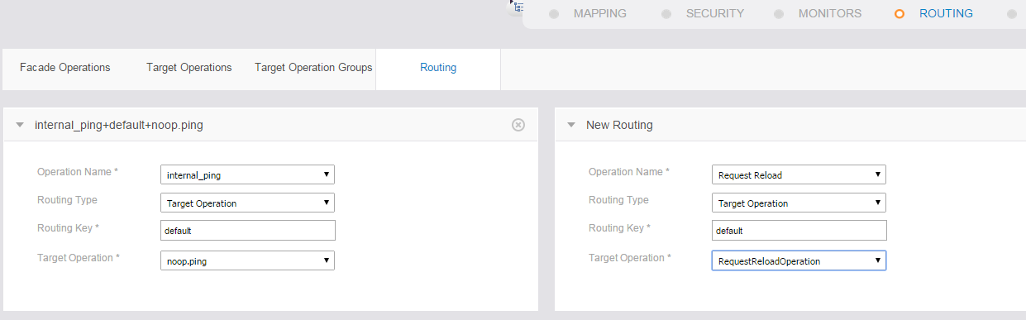

1. Provide Façade access to the required operation unders Partners ->Façade Access Tab as shown below.*(Here we have given access to anon operation for testing purpose)*

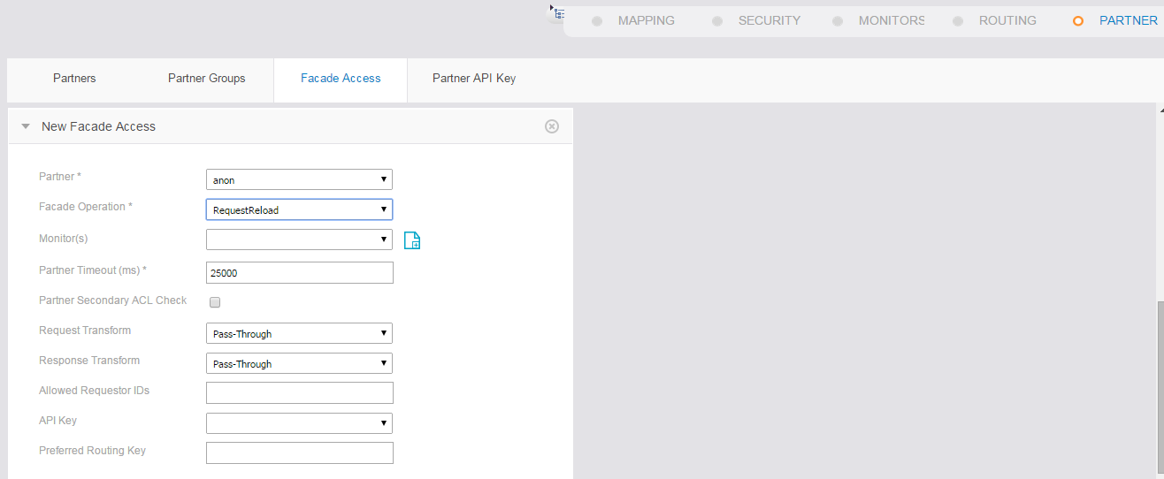

1. Start the ASG engine with the below command

**nohup ./asg-engine -a VanillaReloadScan 2>&1 &**

1. Start the ASG Central logger with the below command

**nohup ./asg-engine –u asg-cl -a VanillaReloadScan 2>&1 &**

1. Multiple partners can be added under partners tab as shown below.

